Website Prototype

Front end and functionality:

Login page:

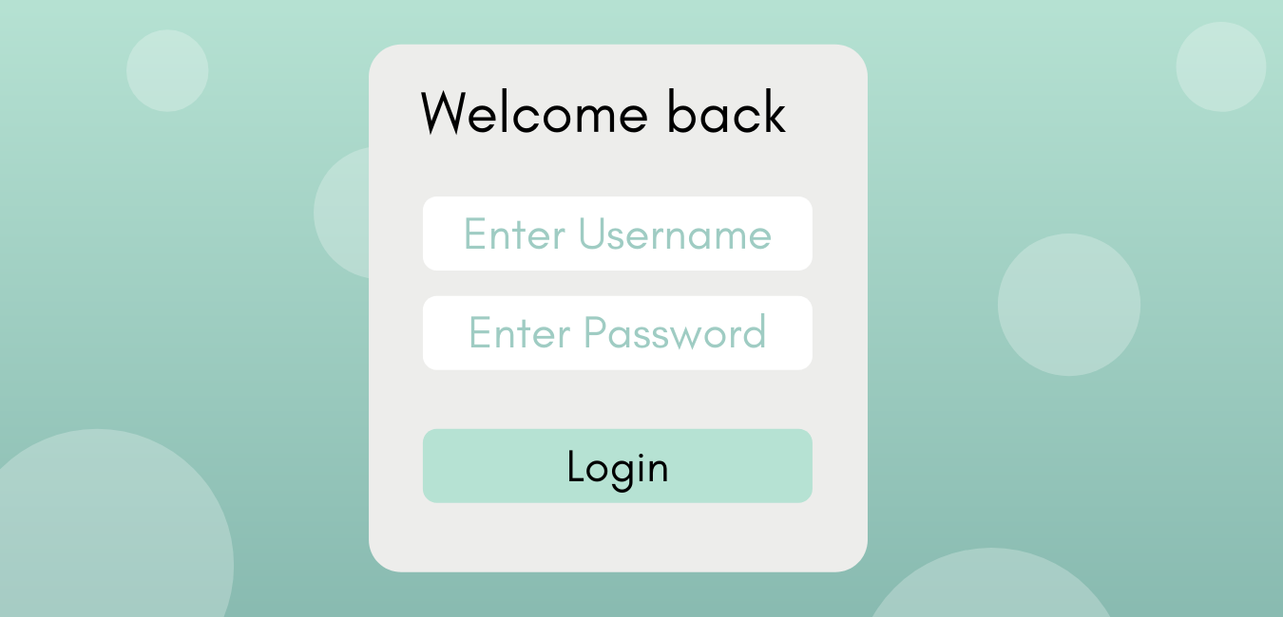

* Functionality
  + Log in using user name and passwordCalendar Page:

Create New Account Page:

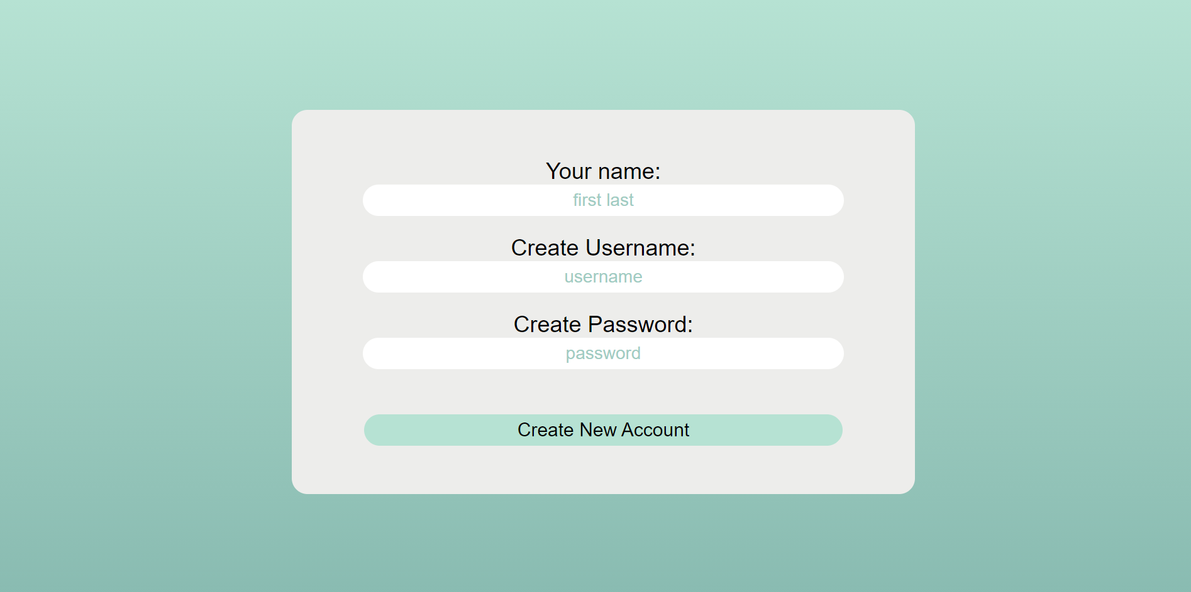

* Functionality: Create a new account

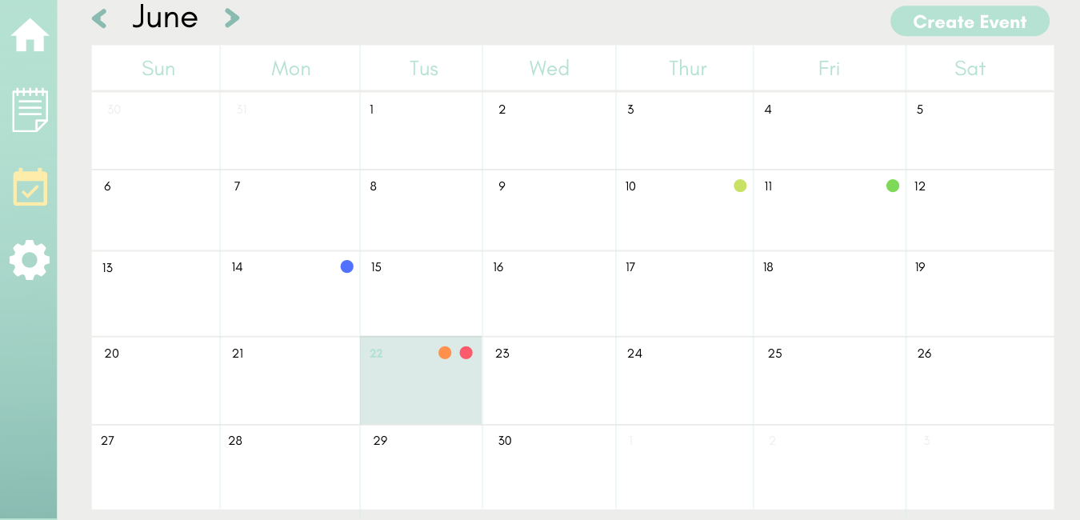

* Functionality
  + View events for any day
  + Switch between months
  + Create future events

Calendar Edit Bar:

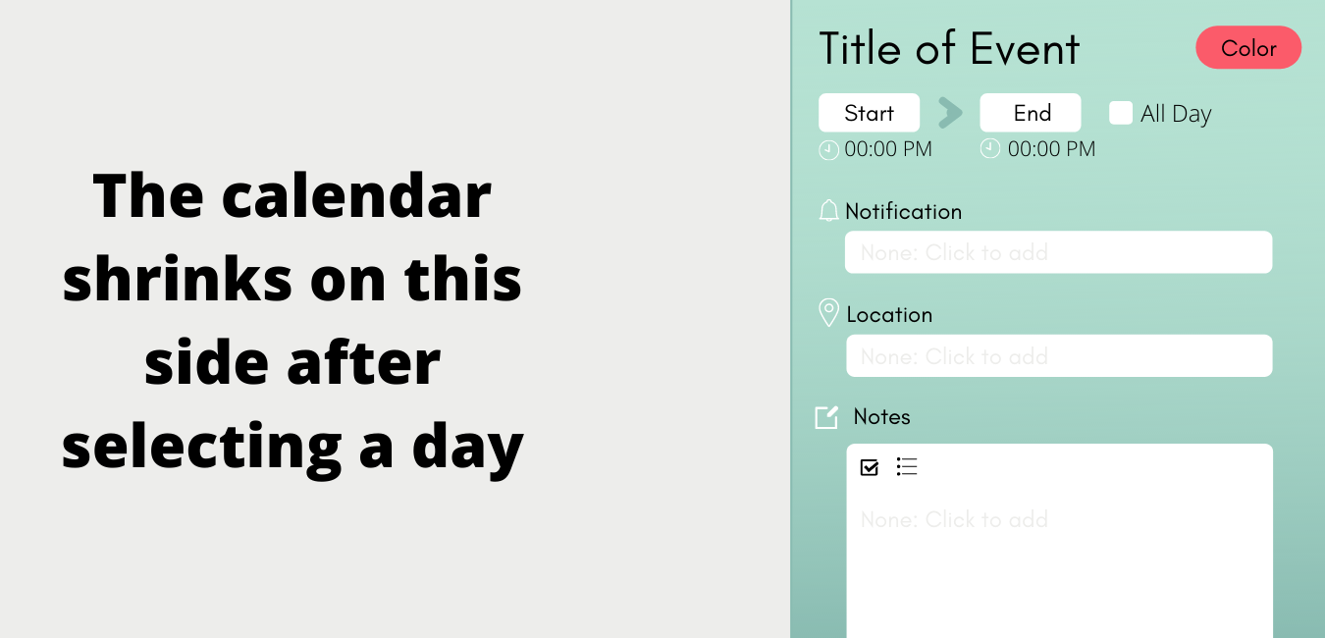

* Functionality
  + Create an event for the day
  + Can select a color for the event to appear on the calendar

Settings Page:

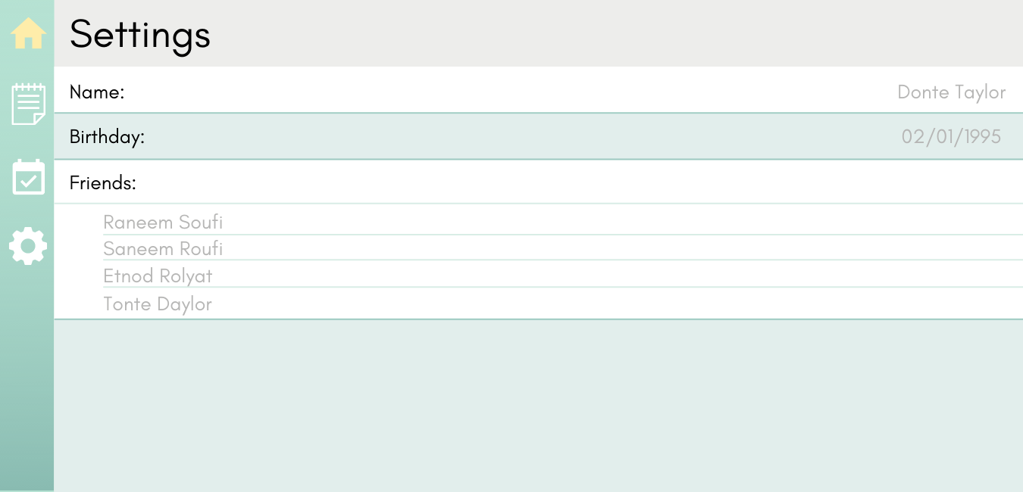

* Functionality
  + View your name, birthday, and friends list
  + Edit any of the settings

Backend/Database:

* A table of all the users, including their name, email, user ID, and password (basically the settings)
* A table of people who are friends with each other
* A table of events
  + Contains name, start date, end date, location, notification, notes, creator, and other people involved in the event